Week 10 Report

Neural Network 01

37237256 薛丁銘

The code of this week is as shown in Figure 1. Here I changed several parameters and I added layers of the network. The result showed that ‘adam’ for the optimizer and ‘sparse_categorical_crossentropy’ for the loss function leads to the best result. After 20 epohs, the accuracy reached 99.76%. The results are as shown in Figure 2.

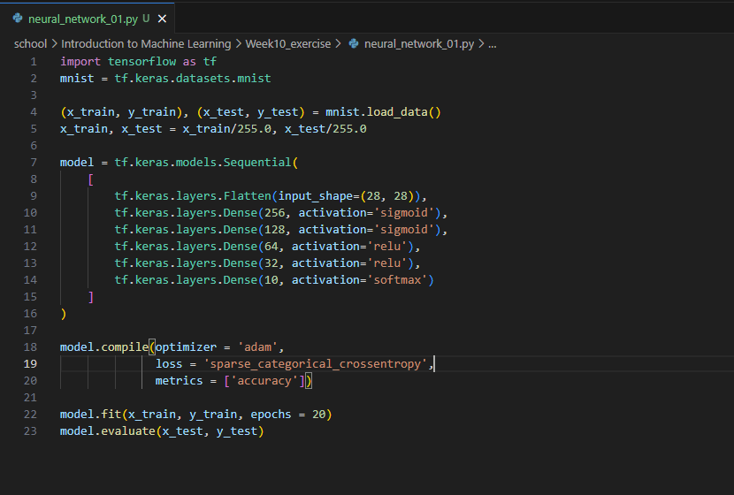

Figure 1. Code

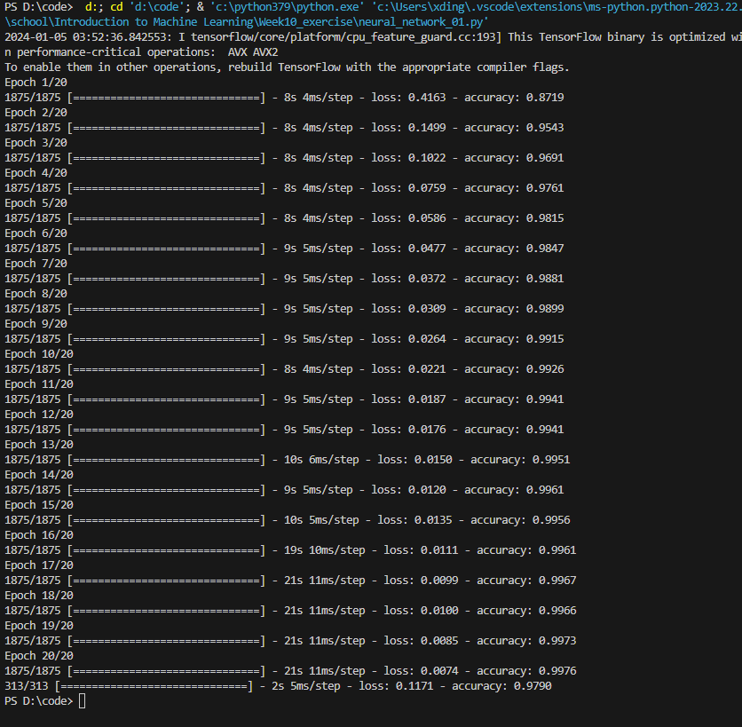

Figure 2. Results